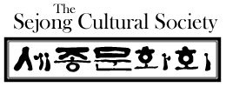

Introduction to Sijo
(Korean Poetry)

Professor David McCann (Harvard University)
Learn about the traditional
Korean poetic form known as the sijo.

Saturday, April 10, 2010
11 am – 1 pm
Harold Washington Library Center
Chicago Author’s Room (7th floor)
400 S. State St., Chicago
(312) 948-8939
Free admission for general public
Parking information at
www.SejongCulturalSociety.org

시
조

Enchanted Evening with
Sijo, Wine, and Arts

Featuring sijo readings by:
Professor David McCann
Ellee Pai Hong
Won Jung Park

Saturday, April 10, 2010
6 – 8 pm
Andrew Bae Gallery
300 W. Superior St., Chicago
(312) 335-8601

$30 per person
Reserve your seat online at www.SejongCulturalSociety.org

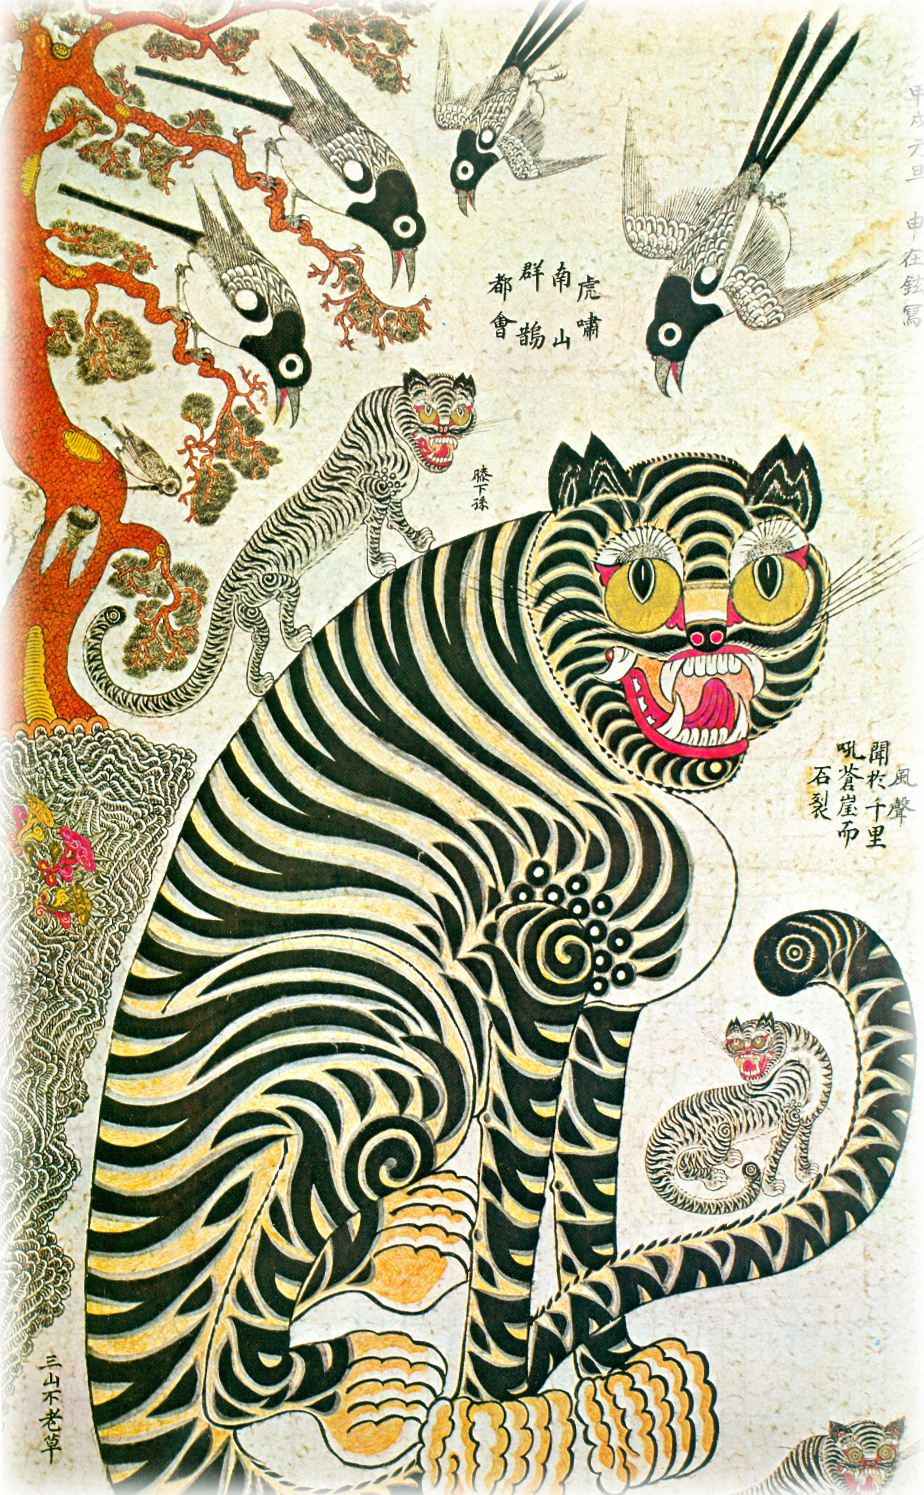

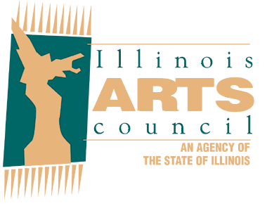
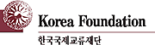

This program is funded by a grant from the Korea Foundation and supported by the Korean Consulate General in Chicago. The Sejong Cultural Society is in part supported by grants from the Illinois Arts Council.

